Implementation of Reflection Agentic Pattern using Groq LLM
https://www.youtube.com/watch?v=0sAVI8bQdRc
~ Prepared by Riya Kharade

Project Title:
Implementation of Reflection Agentic Pattern using Large Language Models

Internship Role:
AI & Cloud Research Intern

Technology Stack:
Python, Groq API, Agentic AI Patterns, Jupyter Notebook

Link:
https://www.youtube.com/watch?v=0sAVI8bQdRc

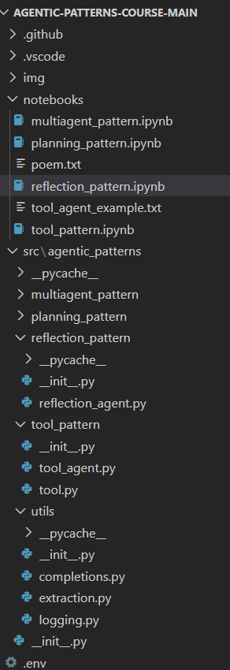

2. Introduction
Agentic AI patterns are structured approaches that allow Large Language Models (LLMs) to behave like autonomous agents capable of improving their outputs over time. This project focuses on implementing the Reflection Agentic Pattern, where an LLM generates an output, critiques its own response, and refines it iteratively.

The implementation is inspired by the DeepLearning.AI definition of agentic patterns and demonstrated practically using the Groq API. The goal of this project is to understand how feedback loops improve response quality and how agent-based workflows can be built using LLMs.

3. Agentic AI Patterns Overview
Agentic AI patterns define how LLMs can operate beyond simple prompt–response behavior.
Common Agentic Patterns:

- Reflection Pattern
- Tool Use Pattern
- Planning Pattern
- Multi-Agent Pattern

In this project, only the Reflection Pattern is implemented and explored in detail.
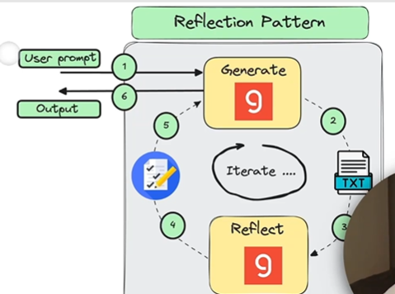
4. Reflection Pattern – Concept
4.1 What is Reflection Pattern?
The Reflection Pattern enables an LLM to:
- Generate an initial response
- Reflect on the generated output
- Provide critique or feedback
- Improve the output based on reflection
- Repeat the loop until a stopping condition is met
This approach significantly improves output quality, correctness, and structure.
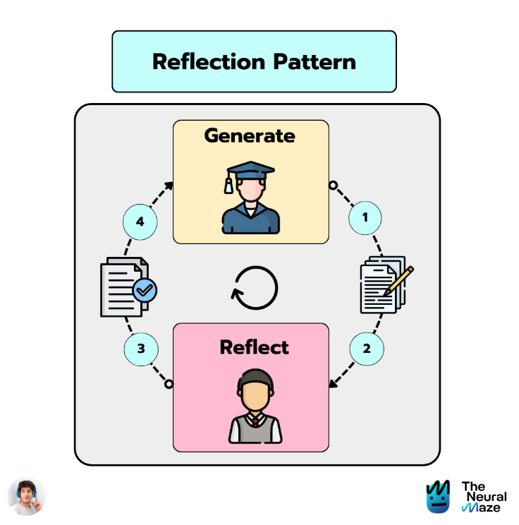

5. Tools & Technologies Used
- Python 3.11
- Groq API (LLM inference)
- Jupyter Notebook
- Agentic Patterns GitHub Repository
- Environment Variables (.env)
- Large Language Models (LLMs)
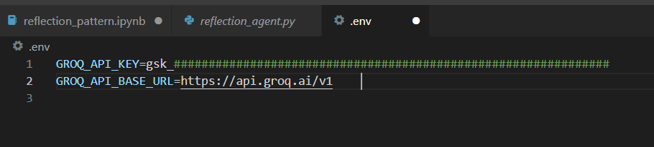

6. Practical Implementation
6.1 Objective
The objective of the practical implementation was to generate and iteratively improve a Python implementation of the Merge Sort algorithm using the Reflection Agentic Pattern.

6.2 Step 1: Initial Code Generation
- A system prompt instructs the LLM to behave as a Python programmer.
- A user prompt requests a Python implementation of Merge Sort.
- The LLM generates an initial version of the code.
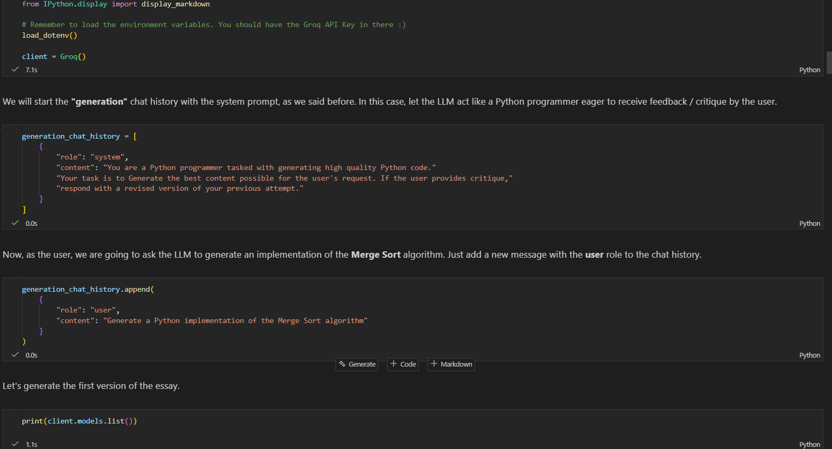
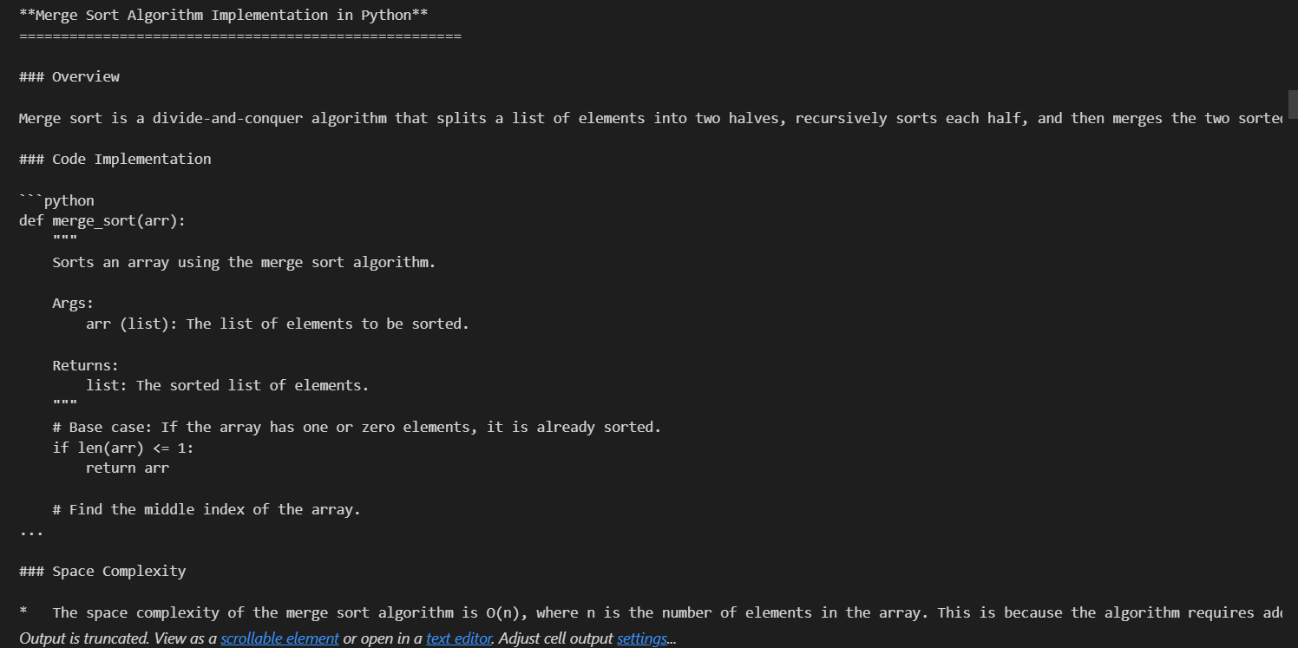
6.3 Step 2:
Reflection Phase
- A separate reflection prompt critiques the generated code.
- Feedback includes:
  - Code readability
  - Naming conventions
  - Documentation
  - Performance considerations
  - Additional test cases
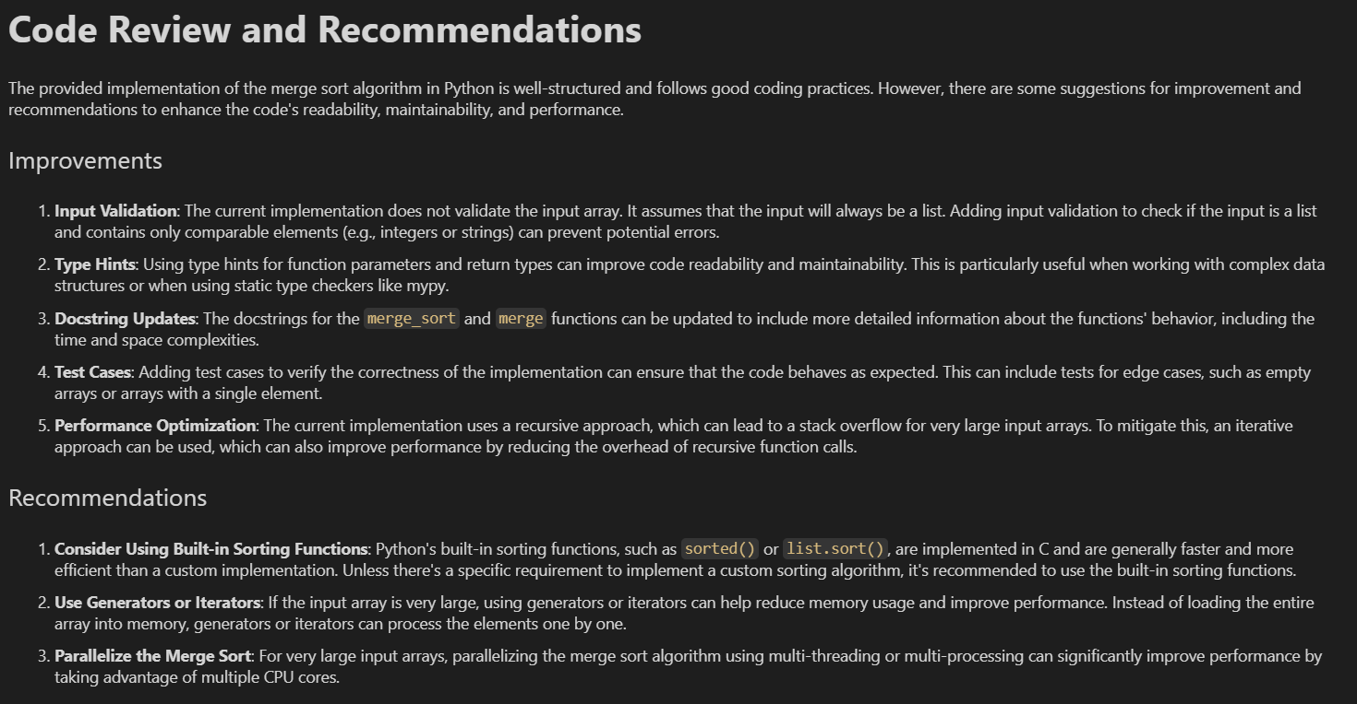

6.4 Step 3:
Improved Code Generation
- The feedback from the reflection phase is passed back to the generation model.
- The model produces a revised version of the Merge Sort implementation.
- Improvements include docstrings, better structure, and example usage.
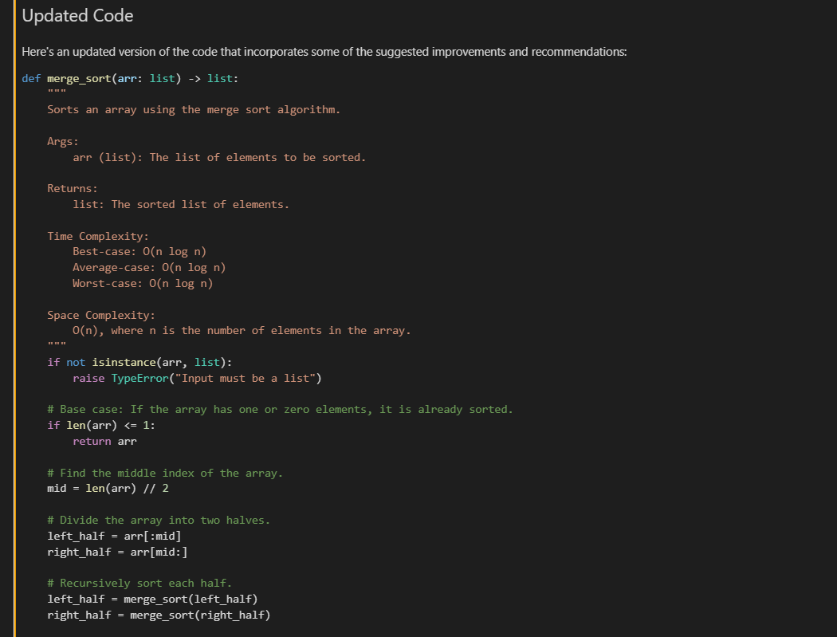

7. ReflectionAgent Class Implementation
To automate the reflection process, a ReflectionAgent class is used.
Responsibilities:
- Manage generation history
- Manage reflection history
- Run multiple iterations
- Control stopping conditions
Key Methods:
- generate() – Generates content
- reflect() – Critiques content
- run() – Executes the reflection loop
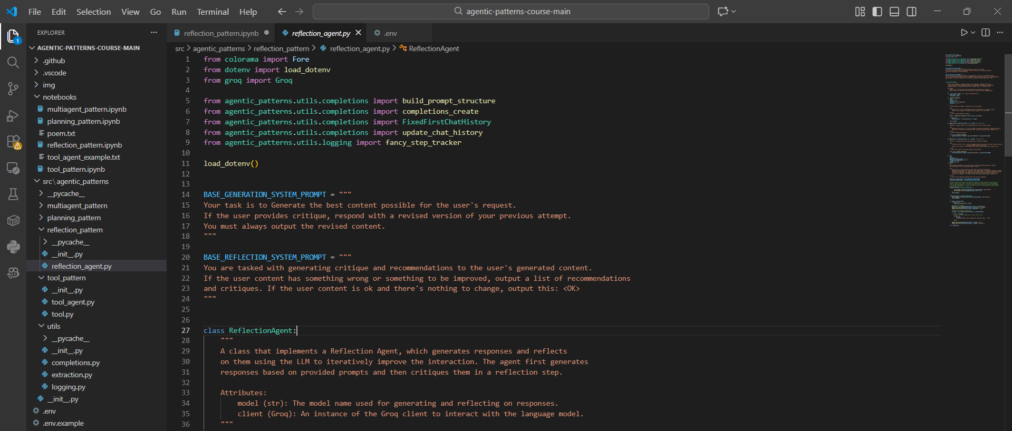

8. Results & Output
After multiple reflection iterations:
- Code quality improved significantly
- Documentation was enhanced
- Additional test cases were added
- Overall readability and robustness increased

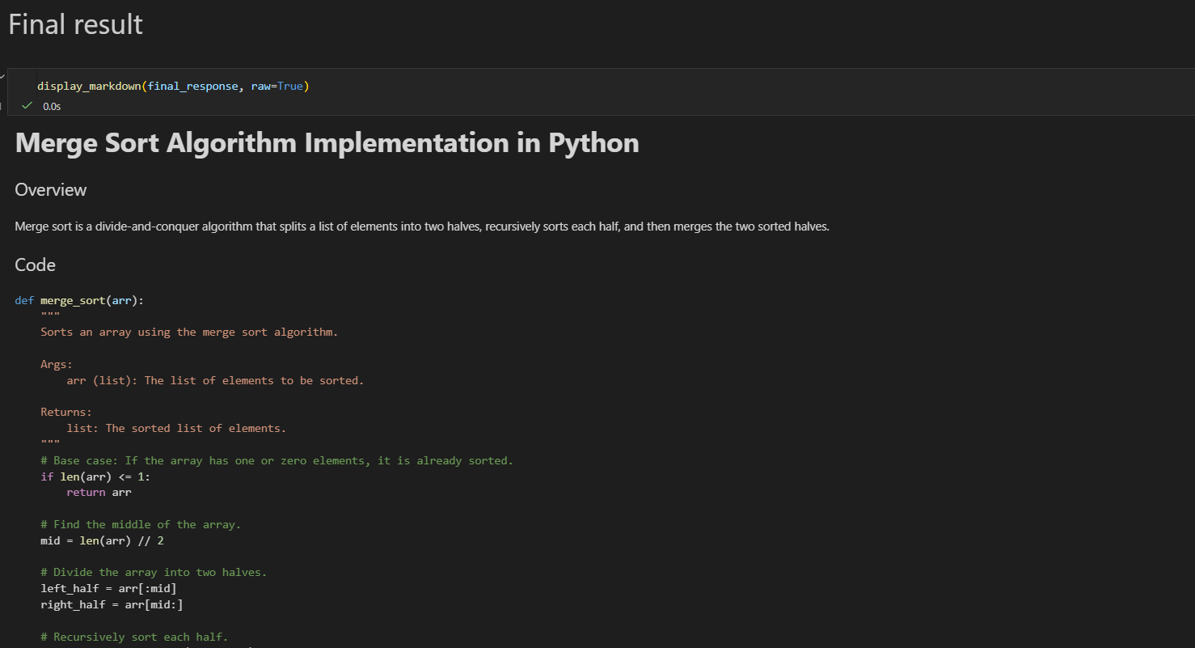
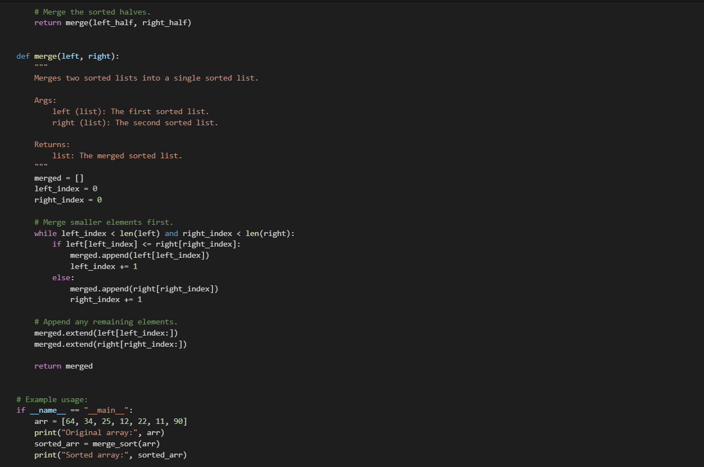

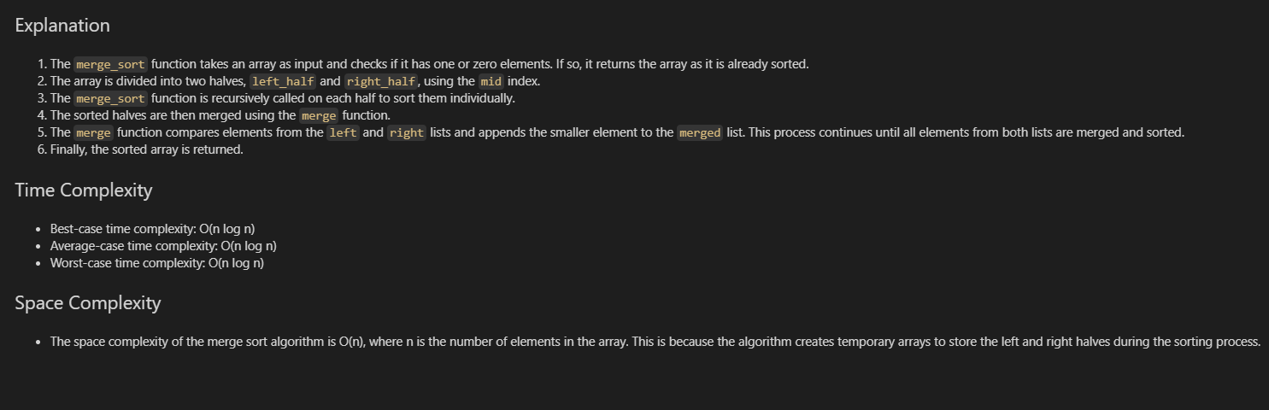

9. Learnings from the Project
- Understanding of Agentic AI patterns
- Importance of feedback loops in LLM systems
- Practical experience with Groq API
- Handling real-world API deprecations
- Building autonomous AI workflows
- Applying agent-based design principles

10. Relevance to AI & Cloud Research Internship
This project demonstrates hands-on experience in:
- Cloud-hosted LLM usage
- Agent-based AI system design
- Iterative AI improvement techniques
- Research-oriented AI experimentation
These skills are directly applicable to AI research, cloud AI services, and autonomous system development.

11. Conclusion
The Reflection Agentic Pattern provides a powerful mechanism for improving LLM outputs through structured self-critique. This project successfully demonstrates how agentic workflows enhance response quality and lays the foundation for more advanced agent-based AI systems.

12. References
- YouTube Video: https://www.youtube.com/watch?v=0sAVI8bQdRc
- DeepLearning.AI – Agentic AI Patterns
- Groq API Documentation
- Agentic Patterns GitHub Repository link
- My Work Link

